**Chapter 2: DataPower Quick Tour and Setup**

Add a note hereIn [Chapter 1](http://www.books24x7.com/assetviewer.aspx?bkid=30903&destid=13#13), [“An Introduction to DataPower SOA Appliances,”](http://www.books24x7.com/assetviewer.aspx?bkid=30903&destid=13#13) we outlined what an SOA Appliance (specifically, a DataPower SOA appliance) is and what it is used for (or should be!). We focused that discussion primarily at the conceptual, more abstract level. Let’s dive in and get our hands dirty. In this chapter, we take a closer look at the devices, and then show you what you should do to get up and running.

**Add a note here****Getting Started with Your New Appliance**

Add a note hereIt is not unlike many technical practitioners to be in a hurry to rip open and install new products as they arrive from the shipping dock. Certainly, lengthy corporate procurement processes can help to build the anticipation! And as we know, many in the technical space prescribe to the mantra “Documentation be damned!”

Add a note hereHowever, despite their reputation for simplicity, appliances like any other product should be carefully planned for and implemented to prevent later rework and reconfiguration. Let’s take a walk through the process.

**Add a note here****Hey Bert, Got a Package for You...**

Add a note hereFor those of us who get excited about technology, it’s a great moment when the device finally arrives in its well-padded shipping container. The contents yield the following:

* Add a note hereDataPower appliance
* Add a note hereRack-mount kit
* Add a note herePower cords
* Add a note hereReference Kit and Documentation CD-ROMs
* Add a note here6′ null-modem female-female serial cable
* Add a note herePrinted installation manual

Add a note hereThe installation manual has the usual dire electrical warnings and other good advice such as not to use the appliance for a “shelf or workspace.” (So you’ll have to find another place for those pictures of the kids.)

**Tip: Read the Manual!**

Add a note hereAlthough experience shows that folks too often don’t, it’s a good idea to temper your excitement for a few moments and read through the short install manual, even though we guide you through the process in this chapter.

Add a note hereThe Resource CD has a great deal of valuable content that should also be examined, and some of the items found on it may have updated versions of the DataPower Web page. Although the contents of the CD change occasionally, some examples of what you might find follow:

* Add a note here**WebGUI User Guide—** This is the most-often used part of the documentation set. It describes the features and usage of the Web administrative console for DataPower, and has a lot of other auxiliary information as well, such as how to interface with IBM DataPower support. Check this document if you’re stuck trying to do something with the CLI, as it often explains configuration choices in more depth than the CLI Guide.
* Add a note here**Example Configurations Guide—** This is the one document that we recommend you read end-to-end. It shows appliance usage and configuration for several example use cases, such as a Human Resources Web Service Portal.
* Add a note here**CLI Reference Guide—** This is a good reference to keep handy when performing administration from the command line, as it provides detailed information on the command syntax and example executions.
* Add a note here**Install Guide—** This is a soft-copy of the printed install guide that comes in the box.
* Add a note here**ITCAM SE for DataPower—** This was described in our first chapter, and we expand on its use later in this book. It is a tool for managing and clustering multiple appliances, and is covered in [Chapter 29](http://www.books24x7.com/assetviewer.aspx?bkid=30903&destid=5160#5160), [“Multiple Device Management Tools.”](http://www.books24x7.com/assetviewer.aspx?bkid=30903&destid=5160#5160)
* Add a note here**Eclipse/RAD Management Plugin—** This tool is a DataPower management plugin to be installed in the Eclipse (including Rational® Application Developer) development environment. It is useful for developers who want to administer their own devices from within their Eclipse workspace.
* Add a note here**Eclipse Co-processing Plugin—** This plugin enables XSLT development done on the Eclipse platform to offload transformations to the DataPower device for testing and debugging.
* Add a note here**XML Spy Plugin—** This achieves the same purpose as the Eclipse co-proc plugin described previously, except it is used for the Altova XMLSpy development product.

Add a note hereThe appliance is a 1U rack-mountable device. All devices in the product line have the same physical characteristics. The printed installation manual has the specifics regarding exact size and weight, and the operating environment and power considerations. Because that information is readily accessible on the IBM product Web site, we won’t repeat it here. Due to the devices’ massive processing power, there is an array of fans to keep them cool. These are variable speed fans and may be somewhat louder at startup or reboot than during normal runtime.

Add a note hereLet’s inspect our newly acquired device. Refer to Figure 2-1 and perhaps the actual appliance pictures in our introductory chapter. Both of these show the appliance with the front bezel plate still attached, but this can be removed for easier access to some of the ports. Referring to the letters in the figure, we see the following features:

* Add a note here**K: Console Port—** This is the DB-9 serial port connector used to initially bootstrap the device. It is hard-wired into a command-line administration shell, as you will see when we move on to initialize the appliance. In some high-security environments, this is the only administrative interface enabled, effectively disabling the ability to do remote administration and forcing the administrator to have physical access to the appliance in the datacenter.
* Add a note here**A, B, C, D, I, J: Link/Activity Lights—** These are on each of the four Ethernet interfaces and show you the network speed and when there is network activity. Their function is described in detail in the Install Guide.
* Add a note here**E: Power Indicator—** This should be green under normal conditions—when the device is turned on and connected to an AC power supply. If the device is powered off, there is no AC power supply (perhaps if it has failed or isn’t plugged in), or there is an over-temperature condition, so this LED will be off.
* Add a note here**F: Storage—** This green LED will be on when auxiliary is being accessed.
* Add a note here**G: Locate—** This blue LED is activated and deactivated by the DataPower firmware, as described in the Install Guide.
* Add a note here**H: Error Alarm—** This yellow LED is illuminated upon device failures as described in the Install Guide.
* Add a note here**L, M, N, O: Ethernet Connectors—** The four RJ45 Ethernet ports, MGMT, ETH0, ETH2, ETH1 respectively, as described in [Chapter 1](http://www.books24x7.com/assetviewer.aspx?bkid=30903&destid=13#13).
* Add a note here**P: PED Port—** This is a port for connecting a PIN Entry Device for use with the optional Hardware Security Module (HSM)[[1](http://www.books24x7.com/assetviewer.aspx?bookid=30903&chunkid=873232052&noteMenuToggle=0&hitSectionMenuToggle=0&leftMenuState=1" \l "ftn.ch02fn01)] that can be ordered with a DataPower device. This port is not present for non-HSM appliances.

[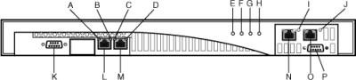](javascript:PopImage('IMG_11','http://images.books24x7.com/bookimages/id_30903/02fig01.jpg','493','111'))  
Add a note hereFigure 2-1: Front face of a DataPower appliance.

Add a note hereLet’s have a look at the rear of the appliance, as shown in Figure 2-2. The two power supplies are visible here, as well as the power switch and fan trays. There are two power supplies for redundancy and high availability. Should one fail (or not be plugged in), the device will continue to operate on the other (and emit warnings in the device log as to the situation). Care must be taken to not block the fan exhausts, or the device will begin to overheat. The components shown in Figure 2-2 are as follows. Their function is described in detail in the Install Guide.

[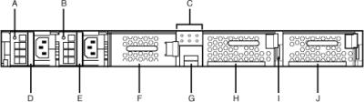](javascript:PopImage('IMG_12','http://images.books24x7.com/bookimages/id_30903/02fig02.jpg','485','136'))

* Add a note hereA, B: Power Supply LEDs
* Add a note hereC: LED Diagnostics Panel
* Add a note hereD, E: Power Supply Modules 1 and 2
* Add a note hereF: Auxiliary Data Storage— Either the hard drives or compact flash used for aux storage.
* Add a note hereG: Battery Tray
* Add a note hereH: Fan Module 2
* Add a note hereI: Power Switch
* Add a note hereJ: Fan Module 1

Add a note hereFigure 2-2: Rear of a DataPower appliance.

**Add a note here****Important Resources Not in the Box**

Add a note hereIt’s best to be aware of all possible resources when doing any kind of work so that if problems occur, you have places to turn for help. We’ve already discussed the resources that come with the product. There are also many others you should be aware of, including the following:

* Add a note here**DataPower Product Home Page—** [www.ibm.com/software/integration/datapower](http://www.ibm.com/software/integration/datapower) is where you find IBM’s home base on the Web for the appliance models. There are sub-pages here for the product Library, News, and Support areas. The Support link in particular has important ‘Flash” notes plus a wealth of pointers to things like technotes, Redbooks®, FAQs, and troubleshooting guides. A critical link on this page is labeled “Firmware and documentation download” and is where you would go to get updated documentation and the system updates for your particular model. Directions on getting product support are also linked from this page.
* Add a note here**Redbooks—** [www.redbooks.ibm.com](http://www.redbooks.ibm.com) has a search box; a query on “DataPower” yields a number of resources, including a Redbook series and other documents related to integration with IBM’s other ESB products.
* Add a note here**developerWorks—** [www.ibm.com/developerworks/](http://www.ibm.com/developerworks/) also yields an extensive list of articles written about DataPower appliances. Some of these are by the authors of the book you are currently reading.
* Add a note here**Public Discussion Area—** [www.ibm.com/developerworks/forums/forum.jspa?forumID=1198](http://www.ibm.com/developerworks/forums/forum.jspa?forumID=1198) is the only discussion area officially sanctioned by IBM. Here, you can find members of IBM’s technical community (tech sales, support, engineering, and field consultants) answering questions on a continual basis. However, this is not formal product support; questions are answered on an ad-hoc basis.

**Add a note here****Next Steps—The Planning Phase**

Add a note hereBefore moving on to our next step, where you actually configure and enable the device, it is best to have some planning discussions with representatives from various areas of your IT department. For example, the network team should be consulted for placement and integration with other network components, firewall ports that need to be opened, and other topics. You need the network team to assign one or more static IP addresses, depending on how many interfaces on the appliances you plan to enable. You need default gateways, possibly static routes, and other network-related information. If you plan on using SSL for network connections, you may need keys and certificates created by your security team or from outside sources. The application teams may have to describe what types of integration will be necessary for their applications—for example, if Web services endpoints will be looked up in a registry dynamically or LDAP servers need to be read for authentication, then ports may need to be open in the firewalls from DataPower to those servers so that the traffic can flow. Plan carefully!

**Add a note here****Next Steps—What You Will Need**

Add a note hereTo do the initial configuration described in the [next section](http://www.books24x7.com/assetviewer.aspx?bkid=30903&destid=211#211), you need the following items (in addition to what came with the appliance):

* Add a note hereA supported serial terminal emulator; alternatively, a Serial-to-USB cable (discussed in the [next section](http://www.books24x7.com/assetviewer.aspx?bkid=30903&destid=211#211)), or serial to RJ-45 adapter if your administration network provides this kind of connectivity
* Add a note hereNetwork information—one or more IP addresses, default gateways, subnet masks, DNS server info, NTP server IP/hostname, and static routes
* Add a note hereMedium cross-tip (Phillips) screwdriver for rack mounting
* Add a note herePower source to plug the device into

Add a note here[[1](http://www.books24x7.com/assetviewer.aspx?bookid=30903&chunkid=873232052&noteMenuToggle=0&hitSectionMenuToggle=0&leftMenuState=1" \l "ch02fn01)]HSMs provide secure, encrypted storage of keys. The appliance’s encrypted firmware and key storage features serve the same purpose; however, the HSM is often ordered with the device to comply with IT Security policies or standards, such as FIPS 140-2 Level 2 and 3.

**Connecting and Powering Up**

Add a note hereThe installation manual has clear instructions and diagrams about the rack-mounting procedure, so we refer you to that document for the hardware installation details. Assuming this has been done, let’s get to the good part. Obviously, a good first step might be to connect the power cords. Do not power on the appliance yet.

**Tip: Power Connections**

Add a note hereWhenever loss of data is a concern, you should have both power cords connected to independent, conditioned power sources. Those redundant power supplies are there for a reason! Failing to do so will result in repeated dire warnings in the DataPower log about a power supply having “failed” when, in fact, the problem is that it is not connected.

Add a note hereAt this point, make your serial port connection. The provided null modem cable can be used to connect to a standard ASCII terminal, but frankly those haven’t been seen much since the 1980s. The usual procedure is to use a workstation with a serial port or use a USB-to-Serial converter cable and attach it to one end of the serial cable provided with the device and the other end to a USB port on your workstation. A typical converter is shown in Figure 2-3. Of course, the other end of the serial cable should be connected to the serial port on the appliance, as shown in [Figure 2-1](http://www.books24x7.com/assetviewer.aspx?bkid=30903&destid=183#183).

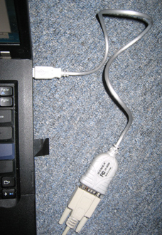  
Add a note hereFigure 2-3: USB-to-serial converter cable attachment.

**Tip: Connect, Then Boot**

Add a note hereOn first initialization, you should always connect the serial cable first, and then power up the appliance. This enables you to see the boot sequence and any error messages that might appear.

**Tip: Don’t Forget That Disc!**

Add a note hereIf you purchase a USB-serial cable, keep the device driver disc that comes with it in your gear bag with the cable. It’s not unusual to have to do this install from other workstations, which may not have the driver for your cable installed. In some high-security environments, there may be no Internet connectivity from the datacenter to download one.

Add a note hereIf you are using Windows®, you may want to verify which COM port the USB serial cable is using. To do this, go to Start→My Computer, right-click, and then click on Manage. The Computer Management applet displays. Click on Device Manager and then open the Ports section. You should see your cable listed and the port it is using, as shown in Figure 2-4.2-5

[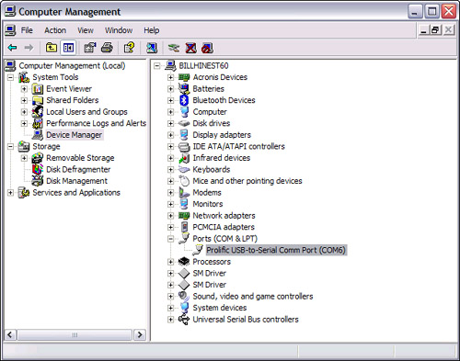](javascript:PopImage('IMG_14','http://images.books24x7.com/bookimages/id_30903/02fig04_alt.jpg','637','501'))  
Add a note hereFigure 2-4: Checking the COM port.

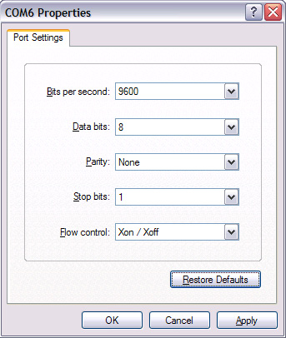  
Add a note hereFigure 2-5: HyperTerminal port settings.

Add a note hereNow it’s time to get a terminal session established. Any ASCII terminal emulation software can be used for this, as the requirements are simple. We use the free Windows HyperTerminal utility. It is typically under Start→All Programs→Accessories→Communications, but if you are going to be doing this a lot, we recommend that you create a desktop shortcut. When HyperTerminal runs, it asks for a name for the new connection. You can use whatever value you find reasonable.

Add a note hereNext, you should see a Connect To dialog, and here you want to change the Connect Using drop-down to the COM port that your cable is using, and then click OK. Now you should be at the Port Settings dialog. Enter the values as shown in Figure 2 (although other flow control settings may work as well, and this may depend on the type of serial cable being used) and click OK.

Add a note hereYou may now fire up the appliance using the power switch on the back. You may notice that initially the fans are quite loud and then decrease in volume as the boot-up sequence progresses. You should now be in the HyperTerminal terminal window. In the lower-left corner, there is a “connected” static string that shows the connection time. If the value there is greater than zero and changing, you are connected. Otherwise, you may have to go to Call→Connect in the menu to establish a connection. When the boot-up sequence finishes, you should be presented with a login prompt. Log in as user admin and provide the password from the instructions included with the device. A license agreement displays; review and accept this if you agree to the terms. Next, you are asked to provide a new password.[[2](http://www.books24x7.com/assetviewer.aspx?bookid=30903&chunkid=968286101&noteMenuToggle=0&hitSectionMenuToggle=0&leftMenuState=1" \l "ftn.ch02fn02)] As we stress in the tip that follows, safeguard this new password and do not lose it! When this is done, you should be at the main prompt, which shows as xi50# for the XI50, as you can see in Figure 2-6.

[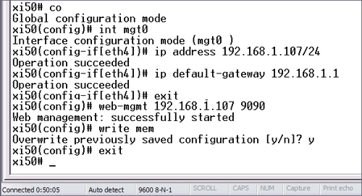](javascript:PopImage('IMG_16','http://images.books24x7.com/bookimages/id_30903/02fig06_alt.jpg','587','319'))  
Add a note hereFigure 2-6: CLI commands for network setup.

**Tip: Never, Never Lose the Admin Password!**

Add a note hereThe admin password for the device is an important thing. If this password is lost, the only recourse is to send the device back to IBM to be reset. Of course, you may still log on to the device with other accounts that may have been created, but there is only one admin superuser account. Safeguard that password carefully!

Add a note hereNow that you are through the preliminaries, our next objective is to configure one of the network ports and enable the WebGUI so that further administration can be done remotely. We cover the Command Line Interface (CLI) admin model in more detail later in the book, so in this chapter, we show you just enough to accomplish these goals. You may also use the DataPower CLI Command Reference as a guide.

Add a note hereThe command sequence is shown in Figure 2-6. We discuss each command in the following list:

* Add a note here**co—** This is a shortened form of the *configure terminal* command. With CLI, you do not need to enter entire, lengthy commands. You need to enter only enough of the command to uniquely distinguish it from any other command. Notice that after this command is entered, the device responds that it is in Global configuration mode, and the command prompt has changed to xi50(config)# to show the current command context.
* Add a note here**int mgt0—** This shortened form of *interface* puts the Ethernet interface designated as mgt0 (or the management port as labeled on the front panel of the device) into configuration mode. You can also type eth4, as this is a synonym for mgt0. The other interfaces are referred to as eth0, eth1, and eth2. (There is not an eth3 between eth2 and mgt0/eth4.) Although any interface could be used for administration, for clarity and to avoid confusion you should use the one labeled “MGMT” on the front of the device, which is mgt0. The device responds with a prompt describing the new context.
* Add a note here**ip address—** With this command, we set the listening IP address for the adapter that we are configuring (mgt0). The dotted quad notation is used, along with a slash and the subnet in CIDR notation. These will be described in [Chapter 3](http://www.books24x7.com/assetviewer.aspx?bkid=30903&destid=308#308), [“DataPower as a Network Device,”](http://www.books24x7.com/assetviewer.aspx?bkid=30903&destid=308#308) along with more detail on configuring these interfaces. If you don’t know CIDR, you can use a dotted quad notation for the subnet as well—for example, ip address 192.168.1.107 255.255.255.0. You would normally obtain an IP address and this other related information from your network team.
* Add a note here**ip default-gateway—** This command establishes the default gateway for this adapter. In some cases, this is the same address as the IP of the adapter, with a .1 as the last node in the quad. However, it’s always best to check with your network team and get this information at the time you obtain an IP address, rather than guess at it.
* Add a note here**exit—** This command applies any changes that have been made and takes us out of configuration mode for mgt0 and drops us back into global configuration mode.
* Add a note here**web-mgmt—** This command enables the Web administration console to listen only on the IP address that we have established for mgt0 (see tip that follows) and on the typical port of 9090. Some shops may want to use a port other than the well-known default port, and that can be designated here in place of 9090. The device listens only on SSL for the WebGUI.
* Add a note here**write mem—** This saves the configuration to the persistent flash memory of the appliance’s file system. Until you use this command, the settings will be active only in the running configuration. The settings actually become “live” when you exit out of a particular administration area, as we did with the exit command two commands ago.
* Add a note here**exit—** This drops us out of global configuration mode. If you are done with the session, enter the exit command one more time to leave the terminal session and go back to the login prompt. This is *very* important for security reasons; you don’t want the next person to connect via the serial port to find a conveniently logged in session under your ID. *Always* completely exit the console session!

**Tip: Be Sure to Use a Real IP Address**

You cannot just guess at an IP address to assign to these interfaces. For example, you might find that your workstation is using 192.168.1.100 and think, “Well, I’ll just use 192.168.1.500.” IP addresses must conform to strict guidelines and be legitimate values in correlation with their subnet mask values. They must not be within the DHCP range for your network, or the DHCP server may give that same address out to another adapter on the network, causing an outage. You can use DHCP instead of a static IP address so that the appliances get an address dynamically at startup, but this is uncommon for server-type devices.

**Tip: Never Use 0.0.0.0**

Although many examples you may come across for enabling the WebGUI and other administrative interfaces on the device will show 0.0.0.0 being used as the listening IP address, we strongly urge you not to do this. This means that the appliance will listen on all configured interfaces on the device for administrative traffic. For example, you could access the WebGUI from the adapter designated for client traffic. It is a good security practice to segregate admin traffic from application traffic so that the rest of the world cannot discover your admin interfaces. You could argue that they would still need a password to do anything, but why allow them to get halfway there? Set up a management interface and enforce strictly that all administrative traffic flows through it.

[[2](http://www.books24x7.com/assetviewer.aspx?bookid=30903&chunkid=968286101&noteMenuToggle=0&hitSectionMenuToggle=0&leftMenuState=1" \l "ch02fn02)]If you are using hardware series 9004 or above, you will be prompted to run the Install Wizard. We will demonstrate device setup without this, so as to be compatible with all current models.

**DataPower WebGUI Administrative Console Quick Tour**

Add a note hereNow that we have assigned an IP address and default gateway to the management interface and enabled the WebGUI administrative console, we can use the console for further changes. In your favorite Web browser (ours is Mozilla Firefox), go to the address https://<ip\_address\_of\_mgt0>:<port>. Notice that this is https rather than http. You have to use the address and port that you assigned to web-mgmt in the CLI session. The login page is shown in Figure 2-7, although this particular one has been customized a little with some descriptive text. We show you how to do that in a bit.

[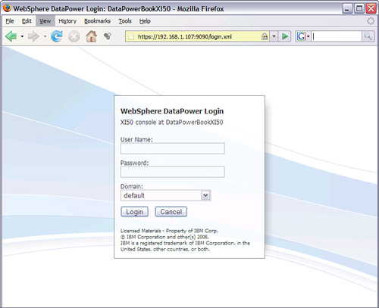](javascript:PopImage('IMG_17','http://images.books24x7.com/bookimages/id_30903/02fig07_alt.jpg','742','604'))  
Add a note hereFigure 2-7: DataPower WebGUI console login page.

Add a note hereYou will notice that in addition to the typical user and password fields, there is a drop-down called “Domain.” The only domain currently is called *default*, as shown in Figure 2-7. Domains are areas of runtime isolation that are somewhat analogous to separate Java Virtual Machines in an application server. They allow your configurations (which are in general proxies to backend applications) to be separated from each other (or grouped together) so that their environments can be independently restarted, backed up, administered, and so on. These are described in more detail in [Chapter 12](http://www.books24x7.com/assetviewer.aspx?bkid=30903&destid=2003#2003), [“Device Administration,”](http://www.books24x7.com/assetviewer.aspx?bkid=30903&destid=2003#2003) where you will also learn how to create additional user and group accounts on the appliances. For now, the only thing important related to domains is that the default domain should be used solely for global device configuration, and not for building application proxies. So, we log in to the default domain and continue our initial configuration. Enter the user admin and the new password that you created earlier, and press the Login button.

**Add a note here****Essential WebGUI Components**

Add a note hereAfter logging in to the administrative console, the main page displays. This is broken into several main areas, as shown in Figure 2-8. In the upper-right corner, you can see the following:

* Add a note here**admin@DataPowerBookXI50—** This is a static text string indicating the currently logged in user and device name. Rather than a device name here, your new device may simply show the IP address.
* Add a note here**Domain—** The domain that the current user is logged in to. You may move between domains simply by selecting another from this drop-down, as long as you have privileges to work in the domain you have selected.
* Add a note here**Save Config—** As you make changes using the console, they are applied to the running configuration but are not saved to the persistent flash storage until you click this link. This is equivalent to the write mem command that we used from our CLI session when doing the initial config earlier in this chapter.
* Add a note here**Logout—** This logs the current user out of the console and returns to the login page.

[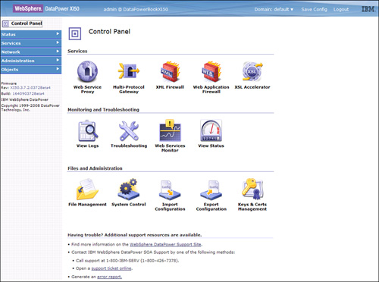](javascript:PopImage('IMG_18','http://images.books24x7.com/bookimages/id_30903/02fig08_alt.jpg','995','740'))  
Add a note hereFigure 2-8: WebGUI Control Panel.

**Tip: Always Remember to Click Save Config**

Add a note hereConfiguration changes are not persisted until this button is clicked. If you do not save your changes and the box is recycled for any reason, your changes will be lost.

Add a note hereThe bulk of the page is dominated by the Control Panel view, a series of categorized icons. You can see in Figure 2-8 that the icons are broken out into groups for Services (application proxies) that can be built, Monitoring and Troubleshooting tools, and File and Administration tools. To return to the Control Panel at any time, you can click the Control Panel link shown in the upper-left corner, which is present in all pages of the console.

Add a note hereThis leaves the final area of the console, which is the left-side Navigation menu. Clicking any of these hyperlinked categories (Status, Services, Network, Administration, or Objects) opens up a contextual sub-menu. There is overlap in functionality between the Navigation menu and Control Panel—for example, you can select and edit a Web Service Proxy through either means; however, while the Control Panel often offers a more streamlined and wizard-like screen flow, the interface exposed by the Navigation menu may offer additional advanced options that are not visible through the Control Panel view of the same object (for example, the capability to enable or disable an object). Note the static text below the Navigation menu in Figure 2-8; this is a quick way to find out what model device and what firmware level the appliance you are currently logged in to is running, and also handily shows the email address for DataPower support.

Add a note hereLet’s explore the Navigation menu more. Clicking on the Status link opens up this section to an amazingly long sub-menu. It would be worthwhile to spend a lot of time here to get a feel for the types of things that can be monitored on the device. In most cases, these would be monitored by some external software, using SNMP or SOAP, but it’s handy to be able to do a quick check using the WebGUI. In Figure 2-9, we clicked on Fan Sensors and can now see relevant information, such as the speed and status of each fan.

[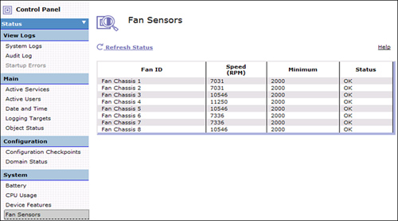](javascript:PopImage('IMG_19','http://images.books24x7.com/bookimages/id_30903/02fig09_alt.jpg','796','441'))  
Add a note hereFigure 2-9: Environmental sensors status.

Add a note hereTwo important items in the Status menu are at the top—the System Logs and Audit Log. The system log in the default domain shows logging activity for every domain on the appliance. It can be filtered down to show activity for specific domains, or for specific types of messages (for example, only log messages related to certificate expiry). The audit log shows when things such as maintenance to keys and certs, firmware changes, and device reboots are done and who did them. It shows all historical information until it reaches its maximum size, at which time the oldest records are truncated. See [Chapter 14](http://www.books24x7.com/assetviewer.aspx?bkid=30903&destid=2478#2478), [“Logging and Monitoring,”](http://www.books24x7.com/assetviewer.aspx?bkid=30903&destid=2478#2478) for more details on saving this log for historical data.

**Tip: Separate Administrative Accounts**

Add a note hereBeing able to capture audit log activity is just one of many good reasons to have separate accounts for each person who will be administering the device. Similar to the root account and password for a Unix server, the admin account should rarely be used and the password for it known only to a few select people.

**Completing the Configuration**

Add a note hereNow that we have completed our initial network configuration and enabled the WebGUI, let’s continue. Note that we have only configured one of the Ethernet interfaces available on the appliance. Certainly we will need more than just that one.

**Add a note here****Completing the Network Config**

Add a note hereWe have configured the first management Ethernet interface using CLI; now let’s finish the network configuration within the WebGUI. We will enable a second interface for application (client) traffic. The network configuration can be changed only while in the default domain, which is where we still are because we haven’t created any other domains. In Figure 2-10, we show the configuration page reached by Network→Interface→Ethernet Interface→eth1. We have entered parameters similar to those we used in the CLI session: the IP address for the interface to listen on and the default gateway. In this screen, we dropped down the Physical Mode list to show the capability to set the speed for a particular interface; in this case we will leave it defaulted to Auto. Keep in mind that when using Auto, the network switch that the device is connected to must also be set to Auto.

[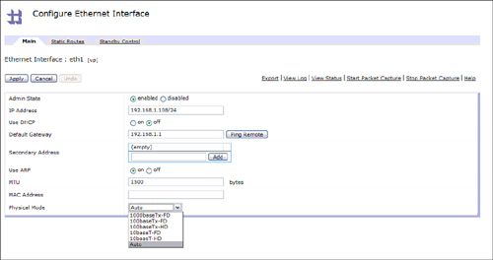](javascript:PopImage('IMG_20','http://images.books24x7.com/bookimages/id_30903/02fig10_alt.jpg','1091','577'))  
Add a note hereFigure 2-10: Ethernet1 configuration.

Add a note hereThe next step in our network setup configures the device for DNS so that hostnames can be resolved. Under Network→Interface→DNS Settings you can see a list of configured servers. Clicking the Add button reveals the entry screen shown in Figure 2-11. We simply need to provide the IP address of a DNS server here and accept the other defaults to add it to the list.

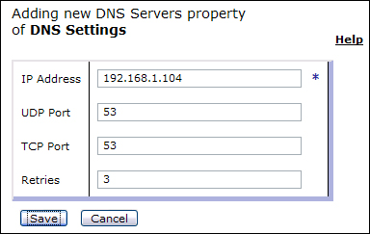  
Add a note hereFigure 2-11: DNS server config.

Add a note hereTo test the DNS config, you can go back to the Control Panel and choose the Troubleshooting icon; on the resulting page, you see a Ping tool, where you can enter a hostname such as [www.google.com](http://www.google.com) and test to see whether it can be resolved and reached by the device.

Add a note hereIt is a recommended practice to configure host aliases for the network interfaces on the device. This helps to keep your configurations more portable. We discuss this in more detail in [Chapter 15](http://www.books24x7.com/assetviewer.aspx?bkid=30903&destid=2720#2720), [“Build and Deploy Techniques.”](http://www.books24x7.com/assetviewer.aspx?bkid=30903&destid=2720#2720) Figure 2-12 shows the two host aliases we built by going to Network→Interface→Host Alias.

[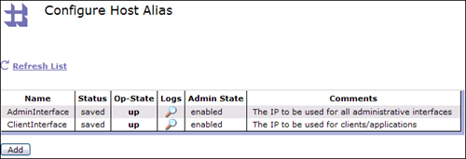](javascript:PopImage('IMG_22','http://images.books24x7.com/bookimages/id_30903/02fig12_alt.jpg','662','226'))  
Add a note hereFigure 2-12: Host Alias configuration.

Add a note hereLet’s look at how to take measures to ensure that the system date and time will remain correct. One common way to do this is to set computer systems in the network infrastructure to use NTP to tie them to some common central NTP server for synchronization.

Add a note hereFigure 2-13 shows how to do this by going to Network→Interface→NTP Settings, clicking the radio button to enable the service, providing the hostname or IP address of an NTP server, clicking the Add button, and then committing the changes. You should also go to Administration→Device→Time Settings to set the correct time zone for the geography in which the device will operate.

[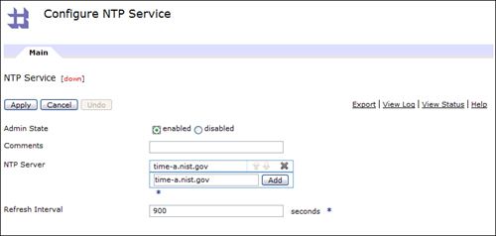](javascript:PopImage('IMG_23','http://images.books24x7.com/bookimages/id_30903/02fig13_alt.jpg','784','373'))  
Add a note hereFigure 2-13: NTP settings.

Add a note hereLet’s continue with the Network menu to turn on the SSH Service so that we can do secure remote command line administration. As shown in Figure 2-14 (reached from Network→Management→SSH Service), we have clicked the Select Alias button to choose the AdminInterface host alias (rather than entering the IP address directly, or worse yet—0.0.0.0!) and then enabled the service with the radio button and clicked the Apply button. Notice in this figure that you can also enter an access control list of client IP addresses that are permitted to connect to the SSH service on the device. This is available for all administrative interfaces.

[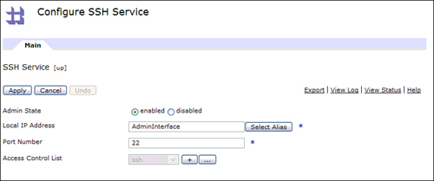](javascript:PopImage('IMG_24','http://images.books24x7.com/bookimages/id_30903/02fig14_alt.jpg','793','332'))  
Add a note hereFigure 2-14: SSH configuration.

Add a note hereSimilarly, the WebGUI settings can be tweaked. Figure 2-15 shows this configuration screen, reached from Network→Management→Web Management Service. This was already enabled in our CLI session, but we have switched the hard-coded IP address to our new host alias and extended the timeout value.

[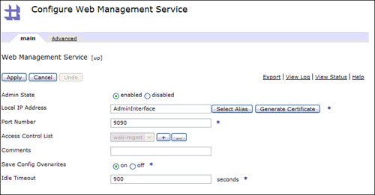](javascript:PopImage('IMG_25','http://images.books24x7.com/bookimages/id_30903/02fig15_alt.jpg','790','413'))  
Add a note hereFigure 2-15: WebGUI configuration.

**Tip: WebGUI Idle Timeout Values**

Add a note hereBe careful with this value. The default is 600 seconds, or 10 minutes. Extending this value means you are decreasing security (for example, in the event someone leaves their workstation unlocked while logged in). While extending this may be acceptable in some development environments, we suggest never using the setting of zero, which means no timeout. When a user logs out (or is timed out), resources such as temp file space are freed up on the device for efficiency. As long as it takes for that to happen, those resources will continue to accumulate.

Add a note hereThe last stop in the Network menu is to turn on the XML Management Interface (discussed in [Chapter 13](http://www.books24x7.com/assetviewer.aspx?bkid=30903&destid=2191#2191), [“Alternate Management Interfaces.”](http://www.books24x7.com/assetviewer.aspx?bkid=30903&destid=2191#2191)) As you may have guessed by now, this is reached by Network→Management→XML Management Interface. Here, you simply specify the Admin Interface host alias again, and enable the service as we have done for SSH and the WebGUI.

Add a note hereWe will do one last bit of housekeeping before we move on. Remember the customized device name (rather than the IP address) that was shown on our login screen in [Figure 2-7](http://www.books24x7.com/assetviewer.aspx?bkid=30903&destid=253#253)? Here’s how you set that. Figure 2-16 shows the configuration from Administration→Device→System Settings. Now you can see where that customized device name shown on the login page is set.

[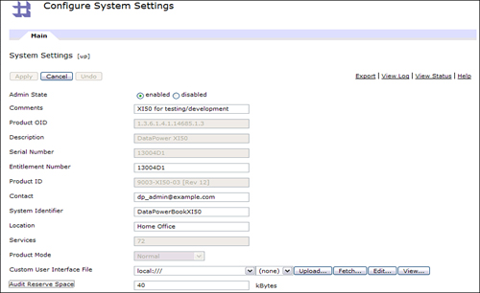](javascript:PopImage('IMG_26','http://images.books24x7.com/bookimages/id_30903/02fig16_alt.jpg','872','533'))  
Add a note hereFigure 2-16: Customizing system settings.

Add a note hereYou may also notice the ability to add a “Custom User Interface File” in Figure 2-16. This feature was added in firmware version 3.7.1. This expands on the capability to add a “welcome message” on the WebGUI page in earlier firmware versions. By editing the custom user interface XML file, you can provide custom text for CLI command prompts and pre-login, post-login, and other appliances messages (for example, “This is the production system; make changes with care!”) for both the CLI and the WebGUI, and also color code those messages on the WebGUI. This feature is well documented in the WebGUI Guide, and it is highly recommended to take advantage of it to reduce the chance of administrators making changes to the “wrong” system!

**Add a note here****Configuring Auxiliary Storage**

Add a note hereIf you are using hardware series 9004 or above, your system is configured with auxiliary storage, which would be either a compact flash card or dual hard disk RAID array. This auxiliary storage needs to be initialized before it can be used. We will provide the configuration sequence for the hard disk array, as it is more complex than the compact flash, and not entirely straightforward or intuitive.

Add a note hereFrom the default domain in the WebGUI, navigate using the left-side menu to Administration→Storage Devices→Hard Disk Array. Select the raid0 array, which should be disabled at this point. From the hyperlink menus, select Initialize Hard Disk Array and then press the Confirm button. Next, select the Initialize File System hyperlink, and press the Confirm button (take note of the warning that this will destroy any contents previously on the disks!). This action will take a minute or two. When it is complete, provide a default directory name and then enable the array. The status should show as ‘up’. The status of the RAID physical disks and volumes can be checked from the Status→System menu. The new directory for the RAID array should appear for each domain under the local and logstore directories.

**Add a note here****Backing Up the System**

Add a note hereBefore we take our last step (update the firmware), let’s back up the system configuration. Even though firmware updates should not affect your configuration in any way, this is always a good idea before making major changes or updates to any computer system. With DataPower, this is simple to do. Figure 2-17 shows that we have gone to Administration→Configuration→Export Configuration and chosen to back up the entire system. Clicking the Next button here takes you to a page that enables you to enter a backup name (this should be something descriptive such as exportFullMyXI50\_3613\_Init\_Config\_<date>) and any comments you want to add. DataPower appends the .zip extension to whatever filename you give it, so don’t include it in the filename. Clicking the Next button on that page results in a brief pause, and then a page appears with a Download button to enable you to download the backup zip file to your workstation. For flexibility and redundancy, you may also want to make a separate backup of just the default domain (although this information is included in a full system backup).

[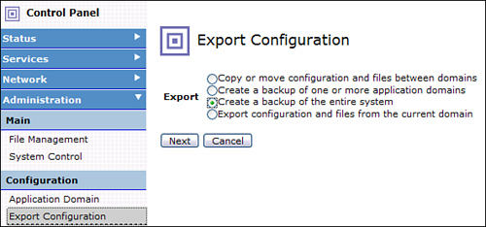](javascript:PopImage('IMG_27','http://images.books24x7.com/bookimages/id_30903/02fig17_alt.jpg','592','277'))  
Add a note hereFigure 2-17: Backing up the appliance.

**Add a note here****Updating the Appliance Firmware**

Add a note hereThe final step in the initial configuration of the device is typically to upgrade the firmware from whatever level was installed in the factory to the latest level. First, check to see whether you are already up to date. You saw in [Figure 2-8](http://www.books24x7.com/assetviewer.aspx?bkid=30903&destid=261#261) how to quickly see what version you have. Also, go to Administration→Device→System Settings and take note of your machine type.

Add a note hereNext, you need to go to the IBM DataPower Web site (the link was shown earlier in this chapter) and check the available firmware levels to see whether there are newer ones. If so, download the firmware file that corresponds to the features that you purchased with your appliance. If you aren’t sure, you can check by going to Status→System→Device Features, which shows which licenses are *enabled* for this device. Do not confuse this with the similarly named menu choice Status→System→Library Information, which shows which features are actually *installed* on the device firmware. For instance, you may have purchased the TAM feature and have that license enabled on your appliance, but if you install a firmware image without it, then it will not actually be installed. (This can always be fixed by downloading a firmware image with that feature.)

Add a note hereOur particular XI50 appliance used for these examples started at version 3.6.1.3 and has licenses for MQ, ODBC, and TAM. From the download site, we have obtained file xi3711.mq6.odbc52.tam6.scrypt2. The filename begins with “xi”, designating that it is for an XI50, then continues with the firmware version (3711 meaning 3.7.1.1), the features included (MQ v6, ODBC v5.2, TAM v6), and then the scrypt2 extension, which designates the firmware generation for firmware versions above 3.5.x.x.

Add a note hereNow that this update is on our workstation, we will move to Administration→Main→System Control in the Control Panel to do the update. First click the Save Configuration button to ensure that any changes we have made thus far are written to the flash.

Add a note hereThere are three steps to the firmware upgrade process:

1. Add a note hereUpload the new firmware file.
2. Add a note hereReload the current firmware. (This is an important step that is often not taken.)
3. Add a note hereBoot the new image.

Add a note hereFigure 2-18 shows the first two steps of this process. In this figure, the Upload button has already been used to bring the firmware file up to the device. It is now shown in the drop-down list. Once that is done, Reload Firmware should be selected in the Shutdown section and the Shutdown button clicked, as shown. There will be a brief pause, and then a page should display saying “Action Completed Successfully.” Close that page and you will be returned to the login page. (Click the Control Panel link to get there if you are not.)

[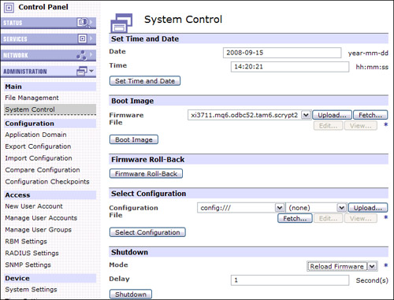](javascript:PopImage('IMG_28','http://images.books24x7.com/bookimages/id_30903/02fig18_alt.jpg','705','537'))  
Add a note hereFigure 2-18: Uploading the firmware update file.

Add a note hereLog back in to the device and return to Administration→Main→System Control. Reselect the uploaded firmware image in the Boot Image section, and then press the Boot Image button. You get a Confirm page, and from there it takes a few minutes to actually apply the update. We do mean a few minutes, so be patient!

Add a note hereWhile this is typically much faster than a standard server reboot, there is a lot of intensive action going on behind the scenes. Finally, reboot the appliance (you are prompted at these steps to click an OK button) and then you should be able to load the login page again.

Add a note hereWe think you will agree—this is much faster and simpler than updating the software on a typical server! Figure 2-19 shows that our appliance has now been updated to version 3.7.1.1. (We later upgraded it to 3.7.2 for you to have the most up-to-date information.) You may also want to capture another backup at this point."Alternate Methods of Updating Firmware"

[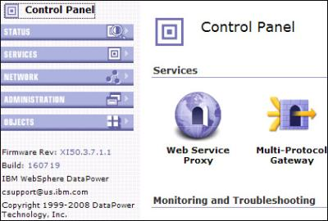](javascript:PopImage('IMG_29','http://images.books24x7.com/bookimages/id_30903/02fig19.jpg','420','284'))  
Add a note hereFigure 2-19: Firmware update completed.

**Alternate Methods of Updating Firmware**

Add a note hereIt may be preferable to upgrade the firmware from the CLI command shell (which is covered in the Alternate Management Interfaces chapter), as it is an intensive operation for a browser-based interface, and the CLI would provide more feedback during the process. There is a detailed technote available on the DataPower support page with instructions on how to do this. Another approach would be to use ITCAM SE for DataPower. As discussed in [Chapter 29](http://www.books24x7.com/assetviewer.aspx?bkid=30903&destid=5160#5160), this utility applies firmware updates across a managed set of devices in a controlled manner.

**Tip: Powering Down the Appliance**

Add a note hereWhile it is rare, any time you need to power down the appliance, you may be tempted to simply flip the power switch on the back. It is a better practice to bring the system to a graceful halt first. To do this, save your configuration, select “Halt System” from the Mode drop-down, as shown in Figure 2-18, and then click the Shutdown button. When the system responds that this is complete, although you will see no physical changes as the lights are still on and fans still spinning, you may then turn off the power switch on the rear of the device. A major advantage of this approach is that you are warned if there are unsaved configuration changes.

## Summary

Add a note hereIn this chapter, we have shown you the entire process of unpacking a brand new device all the way through the initial configuration and prep, including a full backup. We have toured the physical characteristics of the appliance, as well as taken a spin through the main functional areas of the Web administration console. We have enabled two Ethernet interfaces for administrative and client use, performed the initial network configuration, and enabled the SSH and XML Management administrative interfaces. Not bad work for our first hands-on chapter! This concludes [Part I](http://www.books24x7.com/assetviewer.aspx?bkid=30903&destid=12#12), “[DataPower Introduction](http://www.books24x7.com/assetviewer.aspx?bkid=30903&destid=12" \l "12" \t "_parent).” In [Part II](http://www.books24x7.com/assetviewer.aspx?bkid=30903&destid=307#307), “[DataPower Networking](http://www.books24x7.com/assetviewer.aspx?bkid=30903&destid=307" \l "307" \t "_parent),” we further explore the network capabilities of the device and discuss some common usage patterns in the network.